REGULAR BOARD MEETING AGENDA
November 12, 2025 – 5:00 p.m.
Phelan Community Center
4128 Warbler Road, Phelan, CA 92371
& Via Conference Call (see below)

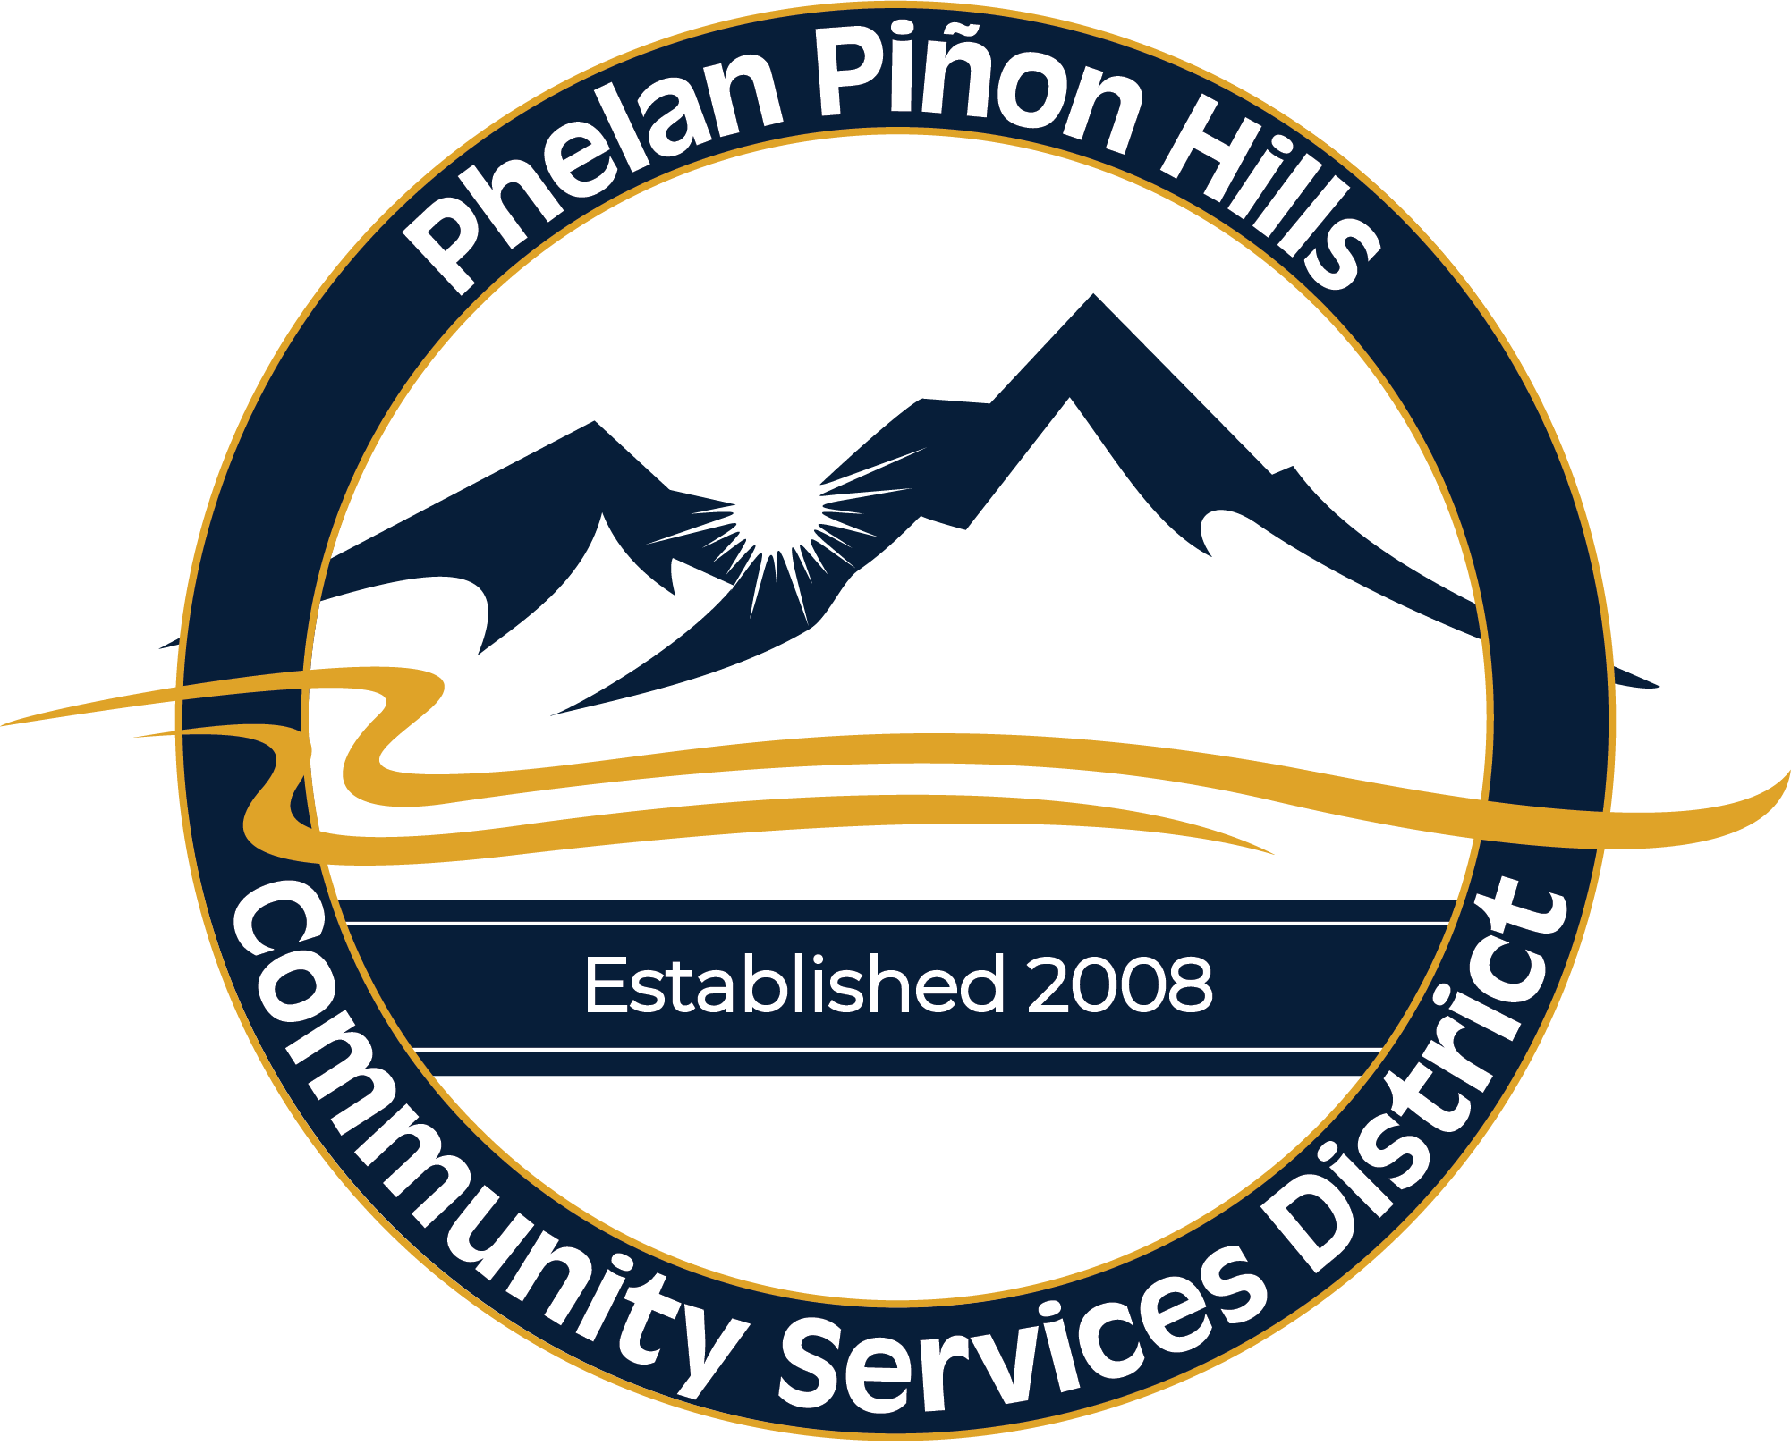
Mission Statement:
The Mission of the Phelan Piñon Hills Community Services District is to efficiently provide authorized services and maximize resources for the benefit of the community.

Authorized Services:
- Water
- Parks & Recreation
- Street Lighting
- Solid Waste & Recycling

REGULAR BOARD MEETING – 5:00 P.M.

Call to Order – Pledge of Allegiance

Roll Call

- Approval of Agenda

- Public Comment – Under this item, any member of the public wishing to directly address the Board on any item of interest that may or may not be within the subject matter jurisdiction of the Board, but not listed on the agenda, may do so at this time. However, the Board is prohibited by law from taking any action on any item not appearing on the agenda unless the action is otherwise authorized by the Brown Act. Any member of the public wishing to directly address the Board on any item listed on the agenda may do so when the item is being considered by the Board. Speakers are requested to be brief in their remarks. The Chair may limit each speaker to a comment period of five (5) minutes.
- General Public
- Community Reports
- C.E.R.T.
- County Supervisor
- Federal Representatives
- Fire
- Mojave Water Agency
- School District
- Sheriff
- State Representatives

- Consent Items
- Approval of Minutes
- Approval of Board Stipends/Reimbursements
- Approval of Contractor Payments
- Acceptance of October Disbursements

- Matters Removed from Consent Items

- Presentations/Appointments
Presentation by Rojas Public Affairs

- Continued/New Agenda Items
- Discussion & Possible Adoption of Resolution 2025-13: For Approval and Ratification of Employee Reclassifications, Promotions and Salary Adjustments
- Update on District Projects

- Committee Reports/Comments
- Engineering Committee (Standing)
- Finance Committee (Standing)
- Legislative Committee (Standing)
- Parks, Recreation & Street Lighting Committee (Standing)
- Waste & Recycling Committee (Standing)

- Staff and General Manager’s Report

- Reports
- Director’s Report
- President’s Report

- Correspondence/Information

- Review of Action Items
- Prior Meeting Action Items
- Current Meeting Action Items

- Set Agenda for Next Meeting
- December 10, 2025
- December 16, 2025 - Special

- Adjournment

Pursuant to Government Code Section 54954.2(a), any request for a disability-related modification or accommodation, including auxiliary aids or services, that is sought in order to participate in the above-agendized public meeting should be directed to the District’s General Manager at (760) 868-1212 at least 24 hours prior to said meeting.

Requests made less than 24 hours before the meeting will be accommodated to the extent feasible.

Agenda materials can be viewed online at www.pphcsd.org

Remote Viewing:
To watch the livestream (view only – nonparticipating), visit our YouTube channel:

PPHCSD YouTube Channel Link

Remote Participation:
To provide public comment, or otherwise participate remotely, select the meeting you wish to attend on the District’s website and then click the “Join Remote Meeting” option.
https://www.pphcsd.org/meetings

Please be advised that remote participation and livestreaming options are provided as a courtesy to the public. Technical issues could occur, resulting in delays or the inability to participate remotely or livestream. It is recommended that you attend in person to ensure you are able to participate.

Written Comments:
You may also email your public comment to the District Clerk at joakes@pphcsd.org by the meeting start time listed on this agenda. Your comment will be added to the record by the District Clerk.

Please check the District website for updates on this meeting. We encourage you to sign up for our email notifications by emailing joakes@pphcsd.org or by visiting our website and completing the signup form at www.pphcsd.org under the “Agendas and Minutes” tab.

