ENGINEERING COMMITTEE MEETING AGENDA
January 21, 2026 – 5:00 P.M.
Phelan Community Center
4128 Warbler Road, Phelan, CA 92371
& Via Conference Call (see below)

ENGINEERING COMMITTEE MEETING – 5:00 P.M.

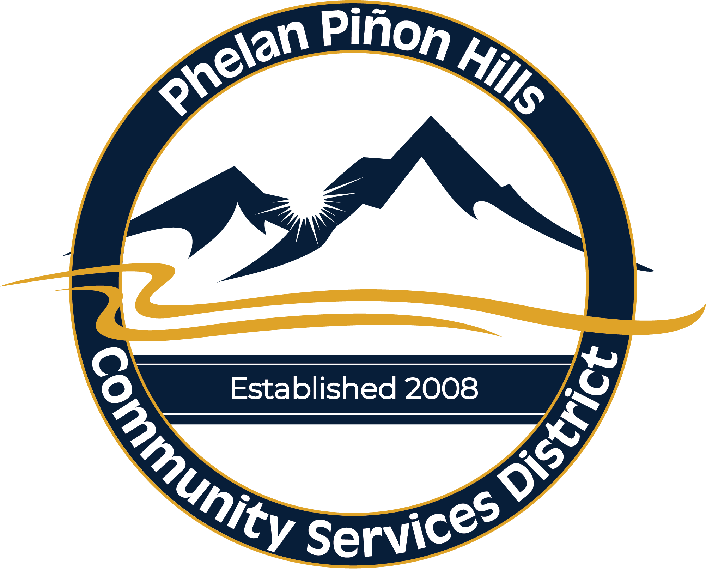
Mission Statement:
The Mission of the Phelan Piñon Hills Community Services District is to efficiently provide authorized services and maximize resources for the benefit of the community.

Authorized Services:
- Water
- Parks & Recreation
- Street Lighting
- Solid Waste & Recycling

Call to Order – Pledge of Allegiance

Roll Call

- Approval of Agenda

- Public Comment – Under this item, any member of the public wishing to directly address the Board on any item of interest that may or may not be within the subject matter jurisdiction of the Board, but not listed on the agenda, may do so at this time. However, the Board is prohibited by law from taking any action on any item not appearing on the agenda unless the action is otherwise authorized by the Brown Act. Any member of the public wishing to directly address the Board on any item listed on the agenda may do so when the item is being considered by the Board. If you wish to address the Board, please do so by the method listed on the first page of this agenda. Speakers are requested to be brief in their remarks. The Chair may limit each speaker to a comment period of five (5) minutes.

- Approval of Minutes

- Review of Committee Roles and Responsibilities

- Review of 10-Year Capital Plan for the 2026/2027 Budget

- Informational – Storm Related Infrastructure Impacts and Preliminary Cost Estimates

- Discussion Regarding Purchasing of a Case Skip loader 570N EP

- Discussion Regarding Water System
- Pumps and Wells Services Agreement
- 10-Year Tank Rehabilitation & Maintenance Service
- Water Quality
- Service Line Replacement Program Update
- Other Repairs/Replacements/Updates/Maintenance

- State Regulations Update

- Review of Current Projects
- Future Well No. 18
- Future Well No. 16
- Tank 6A

- Staff Reports

- Review of Action Items
- Prior Meeting
- Current Meeting

- Set Agenda for Next Meeting – February 18, 2026

- Adjournment

Pursuant to Government Code Section 54954.2(a), any request for a disability-related modification or accommodation, including auxiliary aids or services, that is sought in order to participate in the above-agendized public meeting should be directed to the District’s General Manager at (760) 868-1212 at least 24 hours prior to said meeting.

Agenda materials can be viewed online at www.pphcsd.org

Remote Viewing:
To watch the livestream (view only – nonparticipating), visit our YouTube channel:

PPHCSD YouTube Channel Link

Remote Participation:
To provide public comment, or otherwise participate remotely, select the meeting you wish to attend on the District’s website and then click the “Join Remote Meeting” option.
https://www.pphcsd.org/meetings

Please be advised that remote participation and livestreaming options are provided as a courtesy to the public and technical issues could occur, resulting in delays or the inability to participate remotely or livestream. It is recommended that you attend in person to ensure you are able to participate.

Written Comments:
You may also email your public comment to the District Clerk at awilliams@pphcsd.org by the meeting start time listed on this agenda. Your comment will be added to the record by the District Clerk.

Please check the District website for updates on this meeting. We encourage you to sign up for our email notifications by emailing awilliams@pphcsd.org or by visiting our website and completing the signup form at www.pphcsd.org under the “Agendas and Minutes” tab.

